1. Prepare a U disk（USB driver） with a storage capacity of at least 16 GB

2. Right click and select format... Format U disk to FAT32 format,and change the

Volume label to WINPE ,click start to finish formatting

1. Copy your system files to U disk, and it must be in the root directory of U disk.

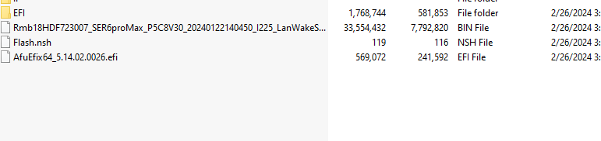

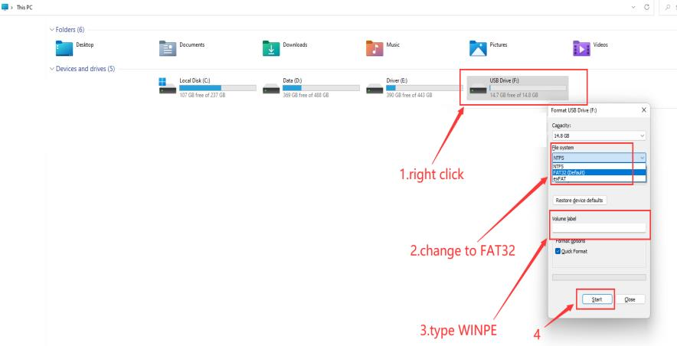

4. Restart the computer, press F7 repeatedly on the boot logo interface, and select

USB boot in the boot options

5.Type fs3: , then press enter

6.Type dir or ls , press enter so that you can locate the files

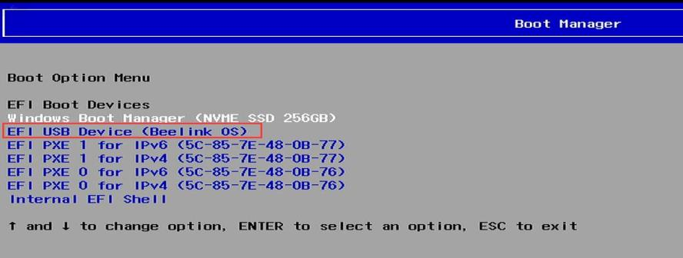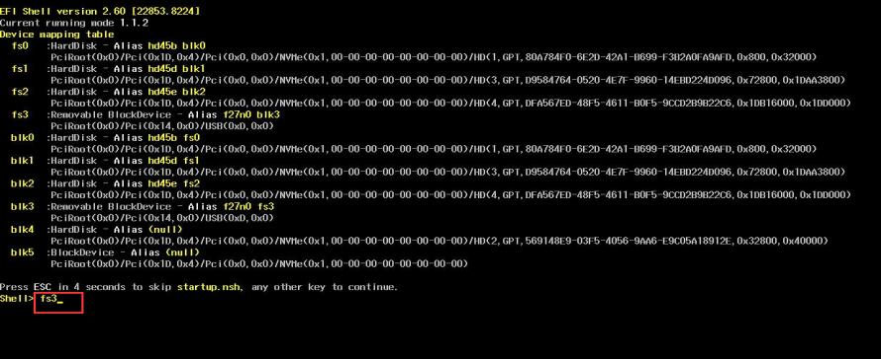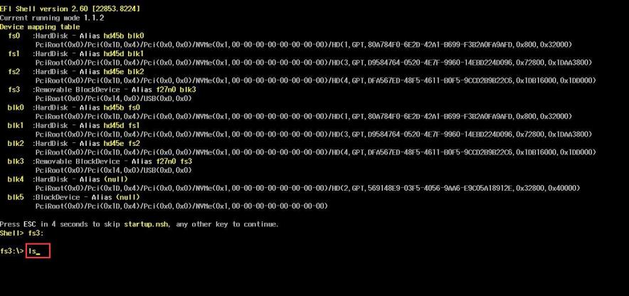

7.Type flash, press tab,then press enter.

8.Start flash, If there is a similar reminder, enter exit.

