1.Prepare the bios files that need to be updated
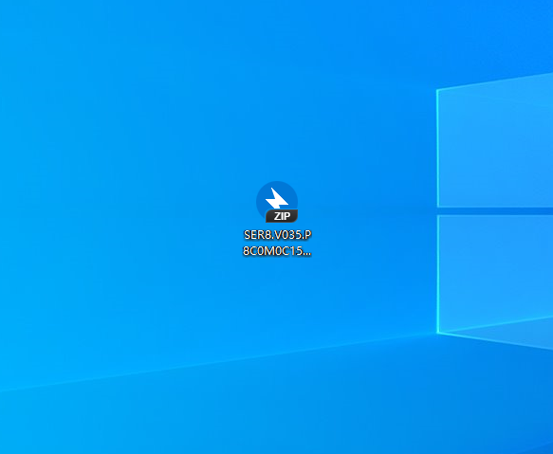

- Extract the zip file to the desktop, the path indicated by the arrow in the figure below，and check “show extracted files when complete”

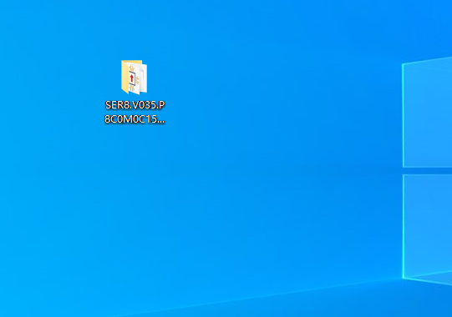

3. Open the file ，Select the address bar and copy the full name (ctrl+c <use keyboard>)
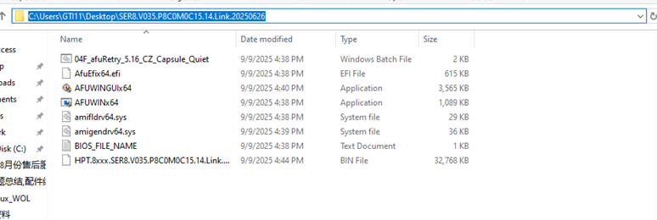

4.Right-click the Windows and select Windows Terminal (Admin)
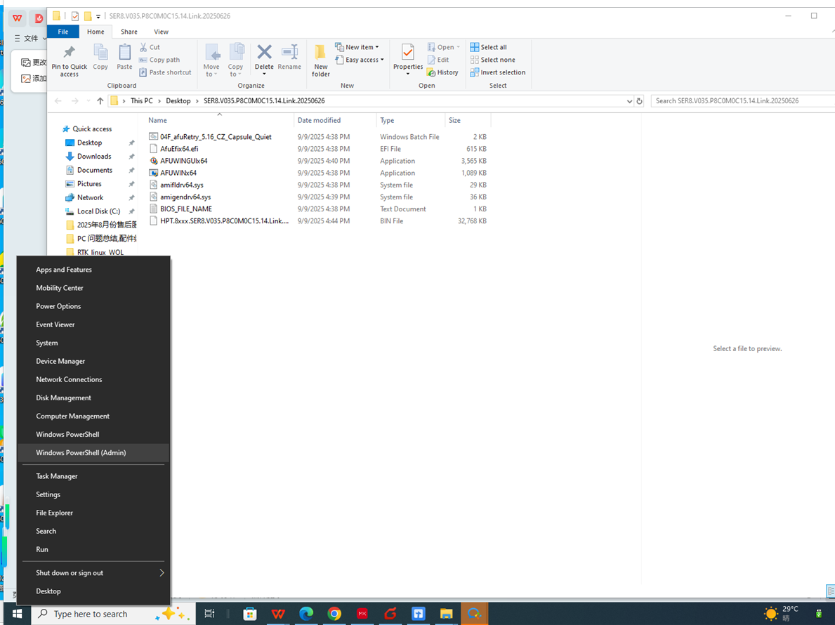

5.Click Yes
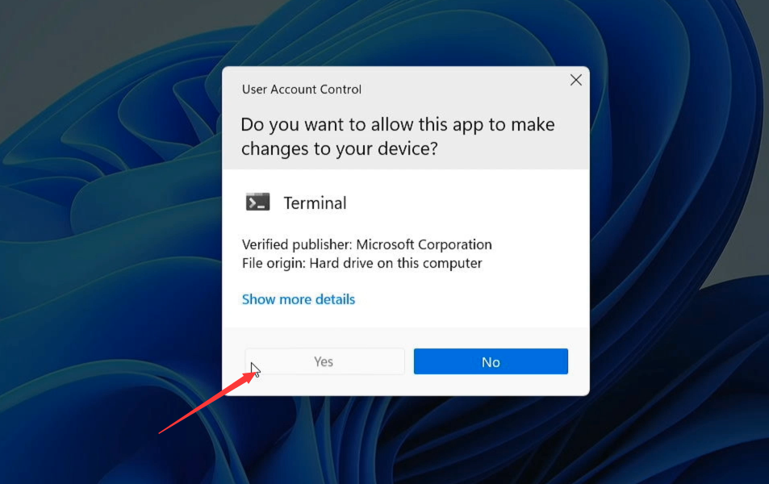
- Type CD then paste the name of the file (ctrl+v) and press the Enter<use keyboard>.

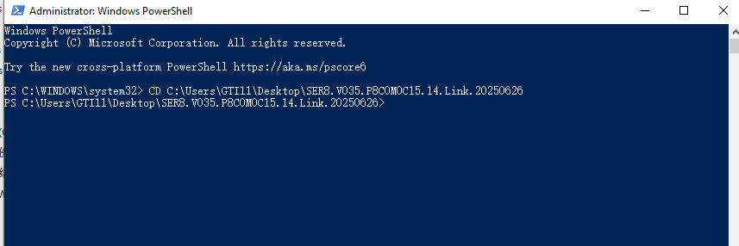

7.Type ls and press the Enter.

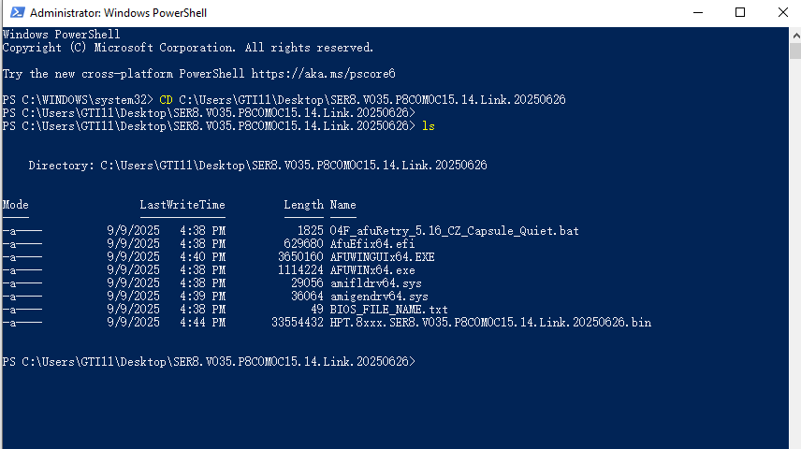
8.Type 04F and press <Tab> then press Enter <use keyboard>.
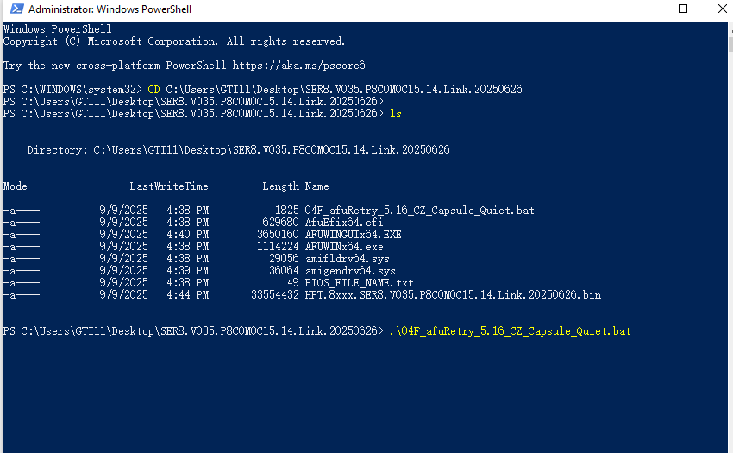

- After flash complete,the computer will restart automatically.

